PRESS RELEASE
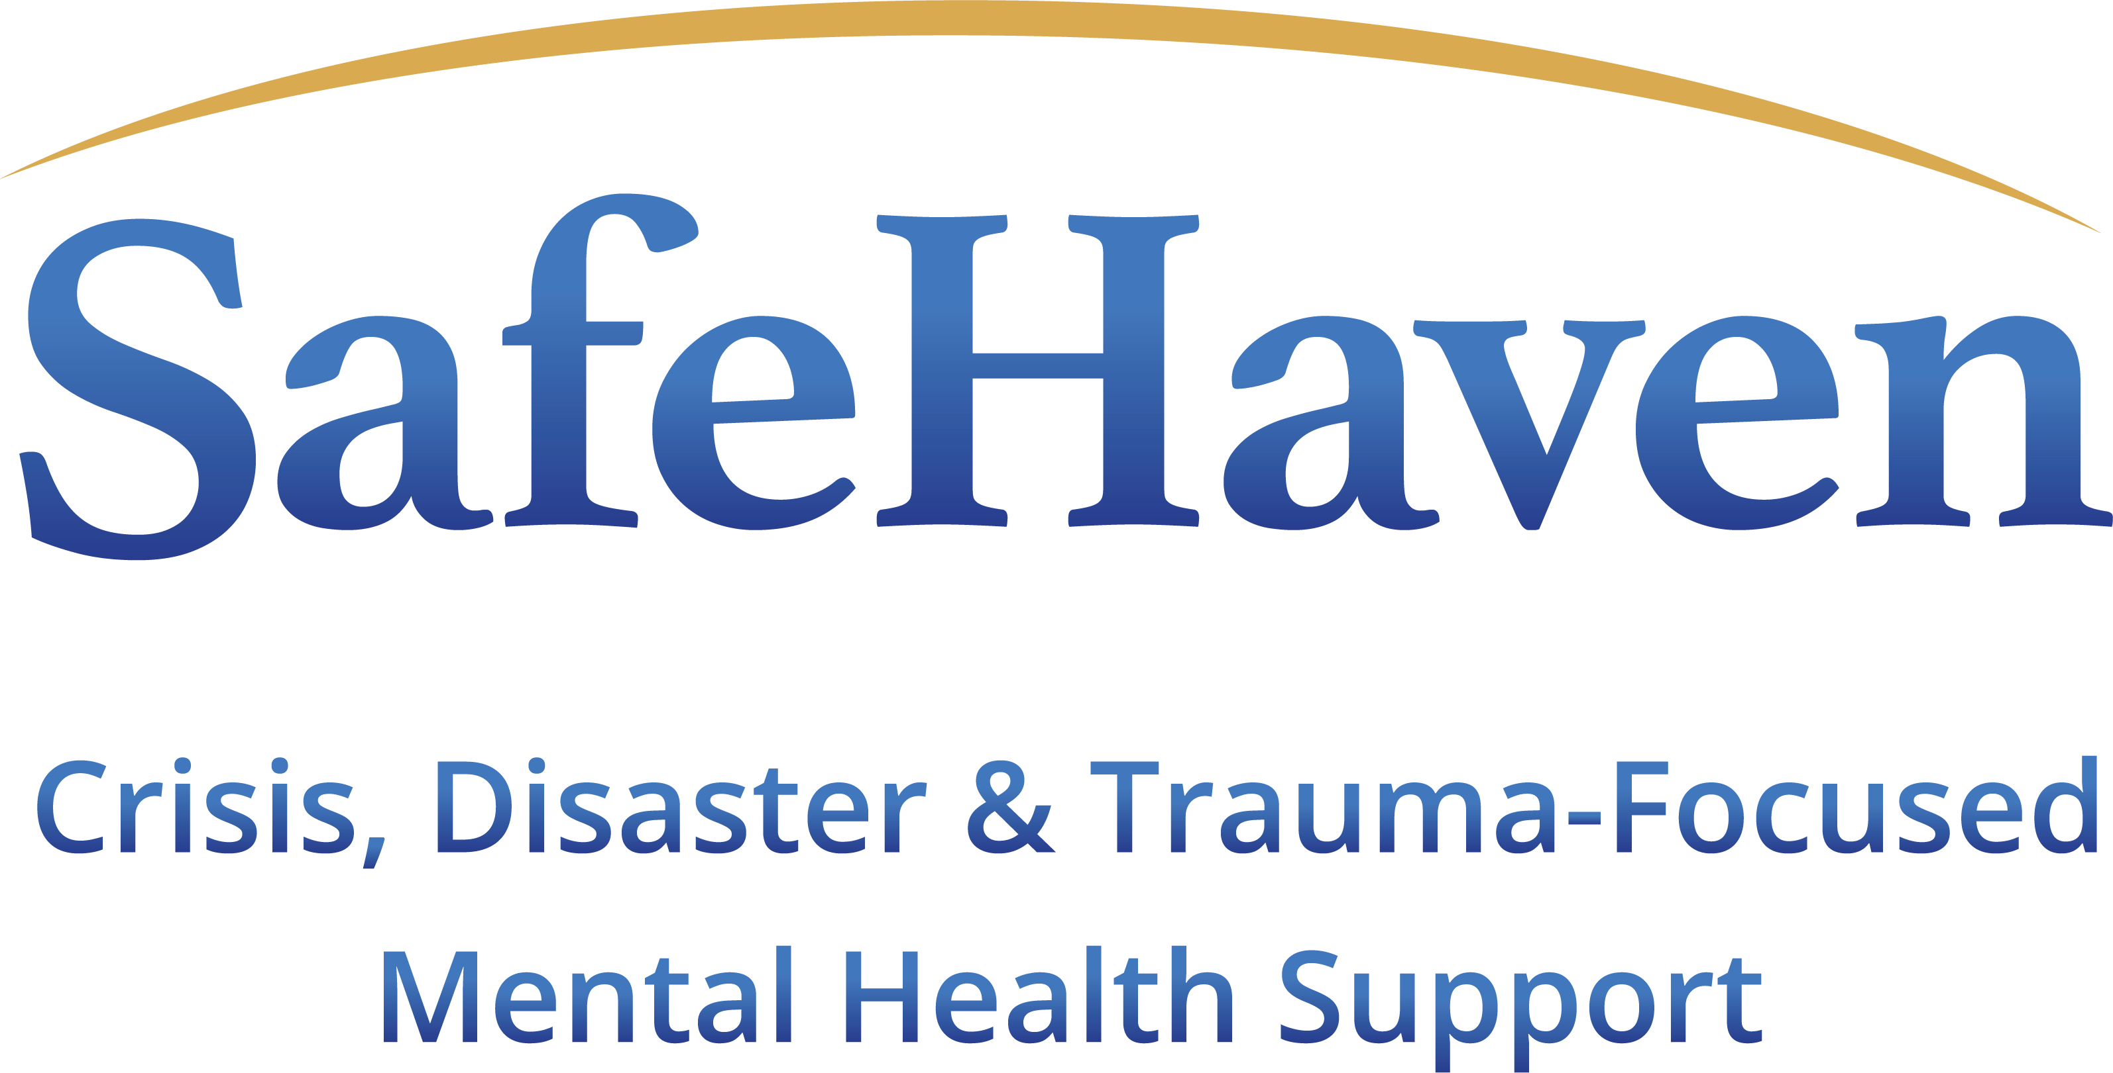
CONTACT INFORMATION:
SafeHaven Critical Incident Stress Management Ltd
Charlotte Copeland
+44 (0)7928 622 722
Charlotte@safehaven.co.uk
FOR IMMEDIATE RELEASE

SafeHaven To Showcase New Mental Wellness App at the International Security Expo

Manchester, September 2021 – SafeHaven CISM is excited to showcase its new trauma-responsive Mental Wellness App at the International Security Expo 2021, Olympia 28-29 September 2021, ahead of the official launch on October 7th.

Developed by psychologists and compliant with international standards and best practice guidelines for supporting the welfare of employees after a critical incident; the new SafeHaven App ensures that employees know what to do to help themselves and others in the vital first few hours and days after an incident or personal crisis.

Not only is the App available around the clock, 365 days a year, but at the touch of a button, it connects users to UK based in-house mental health experts, trauma counsellors and therapists for in-person support when needed. Both immediate, trauma responsive psychosocial support and longer-term psychological sessions can be accessed and arranged confidentially by the user with the SafeHaven team.

In addition, dedicated ‘Hubs’ provide a wealth of expert psychoeducation, including wellbeing videos, playlists, tutorials and guides. This rich depth and variety of expert psychoeducation creates the opportunities for long term behavioural change that reduces stress, anxiety, and really boosts the user’s ability to manage their own mental health.

A management portal helps organisations to tailor, roll out and manage access to the App. This intelligent system provides valuable management information about the health of the workforce, enabling the SafeHaven team to offer guidance on future initiatives, interventions and mitigation measures to stop crises before they begin.

Charlotte Copeland, Managing Director says: “At SafeHaven, we understand the importance of swift, appropriate psychological guidance and support in transforming recovery from physical and emotional distress. The psychological welfare of individuals ripples out to teams and ultimately impacts organisations as a whole. That’s why we created an app that goes so much further than others in the mental wellness space. Not only does it support people in the immediate aftermath of a crisis, but it helps them to understand why the advice and techniques are working for them; empowering individuals to expand and develop their resilience over time whilst adapting to life changes, improving mental health in the longer, as well as the shorter, term.”

For more information about SafeHaven CISM and the SafeHaven App, visit the team on stand Stand D90.

~ends~

ABOUT SAFEHAVEN CISM

SafeHaven are a multi-disciplinary team of mental health professionals who are all specialists in trauma-responsive psychological mental health care. SafeHaven support organisations and their employees, providing the best in trauma-informed proactive and responsive approaches to psychological wellbeing in the workplace, enabling organisations to provide a package of support that meets best-practice guidelines and international standards.

Core services for organisations:
- Crisis and disaster mental health care
- Consultancy on psychological risk management, policy and SOP development
- Workplace peer-network training
- On-call psychosocial response teams
- Telehealth psychological support

Our team members also act as consultants to the media, supporting productions such as the award-winning documentary ‘Once Upon A Time in Iraq’.

They undertake speaking opportunities as Subject Matter Experts on topics such as:

- Psychological crisis response
- Critical incident training for organisations
- Employee welfare
- Post-traumatic stress disorder
- Workplace and vicarious trauma
- Psychological safety
- Workplace mental health

Our Crisis Response service is verified by the International Critical Incident Stress Foundation (ICISF).

SafeHaven have recently worked with USAID in Afghanistan to design, develop and deliver a free, culturally appropriate trauma recovery educational tool to help communities recover from trauma. Training is available in Dari and Pashto, with separate courses for men and women https://trcr.education/

For more information, please visit https://safehaven.co.uk/

